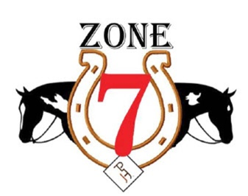

APHA NOVICE YOUTH
High Pt Aria Solemina Chromed Out Sensation
Reserve Hi Pt Lila Schinker Appealing Rose

APHA YOUTH WALK TROT 5-10
High Pt Aliyah Attar Invitation To Ride
Reserve Hi Pt Avery Martin Hidden Zipper

APHA YOUTH 13 & UNDER
High Pt Aria Solemina Chromed Out Sensation
Reserve Hi Pt Lyla McCormick VS Got a Rhythm

APHA YOUTH 18 & UNDER
High Pt Angelica Zizza The American Gigolo
Reserve Hi Pt Lila Schinker Appealing Rose

APHA NOVICE AMATEUR
High Pt Angelina Lieze Face It Fully Loaded
Reserve Hi Pt Taylor McDonough VS Too Die For

APHA AMATEUR WALK TROT
High Pt Leslie Sheetz Party With The Artist
Reserve Hi Pt Alexis Toburen One Macho Cowboy

APHA AMATEUR
High Pt Brandy Barniak Remember It All
Reserve Hi Pt Kristin Roman Wicker Chrome

APHA AMATEUR MASTERS
High Pt Pamela Switzer Sweet Lazy Sensation
Reserve Hi Pt Heidi Novak Hes A Famous Playboy

APHA RANCH YOUTH 18 & UNDER
High Pt Maggie Davidson Gunners Magnum Star
Reserve Hi Pt Autumn Maxwell Its All About Grace

APHA RANCH NOVICE AMATEUR
High Pt Nancy Hollenweger Miss Lil Red Rider
Reserve Hi Pt Donna Franchetti Diamonds N Rust

APHA RANCH AMATEUR
High Pt Nancy Hollenweger Miss Lil Red Rider
Reserve Hi Pt Betsy Ulrich Shirley Its Me
APHA RANCH OPEN
High Pt Betsy Ulrich Shirley Its Me
Reserve Hi Pt Betsy Ulrich Trashy Image

APHA OPEN
High Pt Malley Terryn Flat Sophisticated
Reserve Hi Pt Leslie Sheetz Party With The Artist

